Locus Construction

Definition
# Source: AI Source: Provided by: [Data Path: Persons Table -> ID Column: 1, Name_En Column: Motasem Essam] -> From: [ChatGPT] on [7/25/2026]
Locus Construction is the geometric process of constructing the set of all points that satisfy a given geometric condition.
Instead of merely describing or calculating a locus, locus construction uses geometric construction techniques—such as a compass, straightedge, perpendiculars, angle bisectors, circles, and arcs—to physically or geometrically produce the required locus.
$$\boxed{\text{Geometric Condition}→\text{Construct the Locus}→\text{Required Set of Points}}$$

Simple Definition
# Source: AI Source: Provided by: [Data Path: Persons Table -> ID Column: 1, Name_En Column: Motasem Essam] -> From: [ChatGPT] on [7/25/2026]
Locus Construction is the process of drawing or constructing all possible positions of a point that satisfy a specified geometric condition.
For example:
Construct the locus of all points $P$that are $5$cm from a fixed point $A$.
The condition is:
$$PA=5.$$
Using a compass centered at $A$with radius $5$cm, draw a circle.
Therefore:
$$\boxed{\text{Locus}=\text{circle centered at }A\text{ with radius }5}$$

Fundamental Concept
# Source: AI Source: Provided by: [Data Path: Persons Table -> ID Column: 1, Name_En Column: Motasem Essam] -> From: [ChatGPT] on [7/25/2026]
A locus problem usually has three parts:
- A moving point $P$
- A geometric condition that $P$must satisfy
- The complete set of positions satisfying that condition
The construction process is:
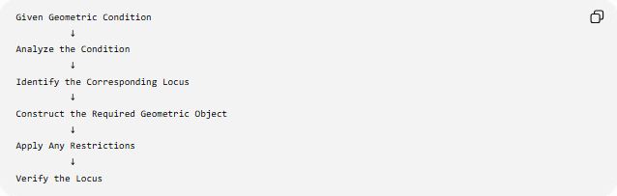
Given Geometric Condition
↓
Analyze the Condition
↓
Identify the Corresponding Locus
↓
Construct the Required Geometric Object
↓
Apply Any Restrictions
↓
Verify the Locus
For example:
$$PA=PB$$
means that $P$is equidistant from two fixed points $A$and $B$.
Therefore:
$$\boxed{\text{Locus}=\text{perpendicular bisector of }AB}$$

Main Types of Locus Construction
# Source: AI Source: Provided by: [Data Path: Persons Table -> ID Column: 1, Name_En Column: Motasem Essam] -> From: [ChatGPT] on [7/25/2026]
A practical classification is:
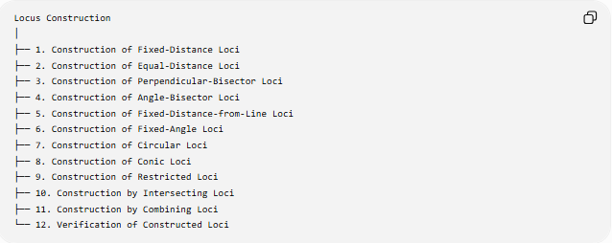
Locus Construction
│
├── 1. Construction of Fixed-Distance Loci
├── 2. Construction of Equal-Distance Loci
├── 3. Construction of Perpendicular-Bisector Loci
├── 4. Construction of Angle-Bisector Loci
├── 5. Construction of Fixed-Distance-from-Line Loci
├── 6. Construction of Fixed-Angle Loci
├── 7. Construction of Circular Loci
├── 8. Construction of Conic Loci
├── 9. Construction of Restricted Loci
├── 10. Construction by Intersecting Loci
├── 11. Construction by Combining Loci
└── 12. Verification of Constructed Loci
These categories describe construction methods and applications, rather than a universally standardized formal classification.

1. Construction of Fixed-Distance Loci
# Source: AI Source: Provided by: [Data Path: Persons Table -> ID Column: 1, Name_En Column: Motasem Essam] -> From: [ChatGPT] on [7/25/2026]
Definition
A fixed-distance locus consists of all points at a specified distance from a fixed point.
If:
$$PA=r,$$
then the locus is a circle centered at $A$with radius $r$.
$$\boxed{PA=r→\text{circle}}$$
Construction
To construct it:
- Mark the fixed point $A$.
- Set the compass to the required distance $r$.
- Place the compass point at $A$.
- Rotate the compass around $A$.
- Draw the complete circle.
Example
Construct the locus of points $P$such that:
$$PA=4\text{ cm}.$$
The result is:
$$\boxed{\text{Circle centered at }A\text{ with radius }4\text{ cm}}$$

2. Construction of Equal-Distance Loci
# Source: AI Source: Provided by: [Data Path: Persons Table -> ID Column: 1, Name_En Column: Motasem Essam] -> From: [ChatGPT] on [7/25/2026]
Definition
An equal-distance locus consists of points satisfying an equality between two distances.
For example:
$$PA=PB.$$
The locus is the perpendicular bisector of $\overset{‾}{AB}$.
$$\boxed{PA=PB→\text{Perpendicular Bisector of }AB}$$
Construction
- Draw segment $\overset{‾}{AB}$.
- Open the compass to a radius greater than half of $AB$.
- Draw arcs centered at $A$.
- With the same radius, draw arcs centered at $B$.
- Let the arcs intersect at $C$and $D$.
- Draw line $CD$.
Then:
$$\boxed{CD=\text{perpendicular bisector of }AB}$$
Every point $P$on $CD$satisfies:
$$PA=PB.$$

3. Construction of Perpendicular-Bisector Loci
# Source: AI Source: Provided by: [Data Path: Persons Table -> ID Column: 1, Name_En Column: Motasem Essam] -> From: [ChatGPT] on [7/25/2026]
The perpendicular bisector is one of the most important constructed loci.
Fundamental Property
For fixed points $A$and $B$:
$$\boxed{PA=PB ⟺ P\text{ lies on the perpendicular bisector of }AB}$$
Example
Let:
$$AB=8\text{ cm}.$$
The perpendicular bisector passes through the midpoint $M$:
$$AM=MB=4\text{ cm}.$$
It also satisfies:
$$CD⊥AB.$$
Therefore:
$$\boxed{M∈CD, CD⊥AB}$$
and every point on $CD$is equidistant from $A$and $B$.

4. Construction of Angle-Bisector Loci
# Source: AI Source: Provided by: [Data Path: Persons Table -> ID Column: 1, Name_En Column: Motasem Essam] -> From: [ChatGPT] on [7/25/2026]
Definition
The locus of points equidistant from the two sides of an angle is its angle bisector.
If an angle has sides $l_{1}$and $l_{2}$:
$$\boxed{d\left(P , l_{1}\right)=d\left(P , l_{2}\right)}$$
then $P$lies on an angle bisector.
For a particular angle, the relevant locus is normally the internal angle bisector.
Construction
- Draw the angle.
- Place the compass at the vertex.
- Draw an arc intersecting both sides.
- From the two intersection points, draw equal arcs.
- Connect the vertex to the arc intersection.
The resulting line is the angle bisector.
It creates:
$$\boxed{∠A_{1}=∠A_{2}}$$
Example
For a ${90}^{∘}$angle, its internal angle bisector creates:
$${45}^{∘}+{45}^{∘}.$$

5. Construction of Fixed-Distance-from-Line Loci
# Source: AI Source: Provided by: [Data Path: Persons Table -> ID Column: 1, Name_En Column: Motasem Essam] -> From: [ChatGPT] on [7/25/2026]
Definition
Given a fixed line $l$, all points at a fixed perpendicular distance $d$from $l$form two parallel lines.
$$\boxed{d\left(P , l\right)=d→\text{two parallel lines}}$$
Construction
- Draw the fixed line $l$.
- Choose a point $A$on $l$.
- Construct a perpendicular to $l$through $A$.
- Mark points $B$and $C$such that:
$$AB=AC=d.$$
- Through $B$and $C$, construct lines parallel to $l$.
The two resulting lines are the locus.
Example
If:
$$d\left(P , l\right)=3\text{ cm},$$
the locus consists of two parallel lines, each $3$cm from $l$.
$$\boxed{l_{1}∥l∥l_{2}}$$

6. Construction of Fixed-Angle Loci
# Source: AI Source: Provided by: [Data Path: Persons Table -> ID Column: 1, Name_En Column: Motasem Essam] -> From: [ChatGPT] on [7/25/2026]
Suppose two fixed points $A$and $B$are given and:
$$\boxed{∠APB=θ}.$$
The locus of $P$is generally a circular arc or arcs through $A$and $B$.
Construction Idea
Since:
$$AB=2R\sin{θ},$$
the radius of the corresponding circle is:
$$\boxed{R=\frac{AB}{2\sin{θ}}}$$
The appropriate arc is then selected according to any restrictions on $P$.
Special Case: ${90}^{∘}$
If:
$$∠APB={90}^{∘},$$
then by Thales' theorem, the locus is the circle having $AB$as diameter.
Thus:
$$\boxed{∠APB={90}^{∘}→\text{circle with diameter }AB}$$
If $P$is restricted to one side of $AB$, only one semicircle is used.

7. Construction of Circular Loci
# Source: AI Source: Provided by: [Data Path: Persons Table -> ID Column: 1, Name_En Column: Motasem Essam] -> From: [ChatGPT] on [7/25/2026]
Many basic loci produce circles.
Fixed distance from a point
$$PA=r$$
gives:
$$\boxed{\text{Circle}\left(A , r\right)}.$$
Two fixed distances
If:
$$PA=r, PB=s,$$
construct:
- circle centered at $A$, radius $r$
- circle centered at $B$, radius $s$
The possible positions of $P$are the intersection points.
This is a fundamental locus construction.
Example
Let:
$$PA=5, PB=4.$$
Construct:
$$C_{1}=C\left(A , 5\right)$$
and:
$$C_{2}=C\left(B , 4\right).$$
Then:
$$\boxed{P∈C_{1}∩C_{2}}.$$
Depending on $AB$, there can be $0$, $1$, or $2$solutions.

8. Construction of Conic Loci
# Source: AI Source: Provided by: [Data Path: Persons Table -> ID Column: 1, Name_En Column: Motasem Essam] -> From: [ChatGPT] on [7/25/2026]
Some loci produce conic curves.
Circle
$$OP=r.$$
Construct using a compass.

Ellipse
An ellipse satisfies:
$$\boxed{PF_{1}+PF_{2}=2a}$$
where $F_{1},F_{2}$are fixed foci.
String Construction
A practical construction uses:
- Two fixed pins at $F_{1}$and $F_{2}$.
- A string of fixed total length.
- Keep the string taut.
- Move a pencil around the two fixed points.
The pencil traces an ellipse.
$$\boxed{PF_{1}+PF_{2}=\text{constant}}$$

Parabola
A parabola satisfies:
$$\boxed{PF=d\left(P , l\right)}$$
where:
- $F$= focus
- $l$= directrix.
A geometric construction can generate points that have equal distance from the focus and directrix.

Hyperbola
A hyperbola satisfies:
$$\boxed{∣PF_{1}-PF_{2}∣=2a}$$
where $F_{1},F_{2}$are fixed foci.
Its two branches can be constructed from the constant-distance-difference condition.

9. Construction of Restricted Loci
# Source: AI Source: Provided by: [Data Path: Persons Table -> ID Column: 1, Name_En Column: Motasem Essam] -> From: [ChatGPT] on [7/25/2026]
Sometimes the complete locus is too large because additional conditions are imposed.
The construction therefore becomes:
$$\boxed{\text{Basic Locus}∩\text{Restriction}}$$
Example
Suppose:
$$PA=5$$
and $P$must lie above line $AB$.
First construct the complete circle:
$$C\left(A , 5\right).$$
Then keep only the portion above $AB$.
The result is an appropriate semicircle or arc.

10. Construction by Intersecting Loci
# Source: AI Source: Provided by: [Data Path: Persons Table -> ID Column: 1, Name_En Column: Motasem Essam] -> From: [ChatGPT] on [7/25/2026]
Many geometric construction problems are actually solved by finding the intersection of two or more loci.
Fundamental Principle
$$\boxed{L_{1}∩L_{2}}$$
contains points satisfying both conditions.
Example: Construct a Triangle from Three Side Lengths
Given:
$$AB=c, AC=b, BC=a.$$
To construct $C$:
- Draw $AB=c$.
- Construct a circle centered at $A$with radius $b$.
- Construct a circle centered at $B$with radius $a$.
- Their intersection gives possible positions of $C$.
Thus:
$$\boxed{C∈C\left(A , b\right)∩C\left(B , a\right)}$$
There can be two symmetric possible positions for $C$.

11. Construction by Combining Loci
# Source: AI Source: Provided by: [Data Path: Persons Table -> ID Column: 1, Name_En Column: Motasem Essam] -> From: [ChatGPT] on [7/25/2026]
Sometimes the answer is a union rather than an intersection.
If:
$$P∈L_{1}$$
or
$$P∈L_{2},$$
then:
$$\boxed{P∈L_{1}∪L_{2}}$$
Example
The complete locus of points equidistant from two intersecting lines consists of two angle-bisector lines.
Therefore:
$$\boxed{L=L_{\text{internal}}∪L_{\text{external}}}$$
The two constructed lines together form the complete locus.

12. Verification of Constructed Loci
# Source: AI Source: Provided by: [Data Path: Persons Table -> ID Column: 1, Name_En Column: Motasem Essam] -> From: [ChatGPT] on [7/25/2026]
A constructed locus should satisfy both directions of the locus relationship.
For a locus $L$:
Necessity
Every point constructed on $L$must satisfy the condition.
For:
$$PA=PB,$$
every point $P$on the perpendicular bisector must satisfy:
$$PA=PB.$$
Sufficiency
Every point satisfying the condition must lie on the constructed locus.
If:
$$PA=PB,$$
then $P$must lie on the perpendicular bisector of $AB$.
Therefore:
$$\boxed{P∈L ⟺ P\text{ satisfies the required condition}}$$
This is what makes the construction a complete locus, rather than merely a collection of example points.

Locus Construction and Classical Straightedge-and-Compass Construction
# Source: AI Source: Provided by: [Data Path: Persons Table -> ID Column: 1, Name_En Column: Motasem Essam] -> From: [ChatGPT] on [7/25/2026]
Locus construction is closely connected with classical geometric construction.
Common tools include:
- straightedge,
- compass,
- arcs,
- perpendicular lines,
- parallel lines,
- angle bisectors,
- circles.
Examples:
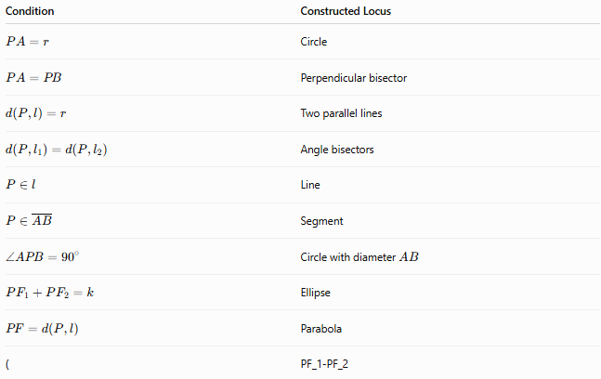
Condition | Constructed Locus
$$PA=r$$ | Circle
$$PA=PB$$ | Perpendicular bisector
$$d\left(P , l\right)=r$$ | Two parallel lines
$$d\left(P , l_{1}\right)=d\left(P , l_{2}\right)$$ | Angle bisectors
$$P∈l$$ | Line
$$P∈\overset{‾}{AB}$$ | Segment
$$∠APB={90}^{∘}$$ | Circle with diameter $AB$
$$PF_{1}+PF_{2}=k$$ | Ellipse
$$PF=d\left(P , l\right)$$ | Parabola
( | PF_1-PF_2

General Locus Construction Strategy
# Source: AI Source: Provided by: [Data Path: Persons Table -> ID Column: 1, Name_En Column: Motasem Essam] -> From: [ChatGPT] on [7/25/2026]
When solving a locus construction problem, use this procedure:
Step 1 — Identify the Moving Point
Usually call it:
$$P.$$
Step 2 — Identify Fixed Objects
These might be:
- fixed points,
- fixed lines,
- fixed segments,
- circles,
- angles,
- vertices.
Step 3 — Translate the Condition
For example:
$P$is equally distant from $A$and $B$.
becomes:
$$PA=PB.$$
Step 4 — Recognize the Standard Locus
$$PA=PB→\text{perpendicular bisector}.$$
Step 5 — Construct It
Use the appropriate straightedge-and-compass procedure.
Step 6 — Apply Restrictions
For example:
$$P∈△ABC.$$
Step 7 — Check the Result
Verify that every constructed point satisfies the original condition and that every valid point is included.

Complete Construction Example
# Source: AI Source: Provided by: [Data Path: Persons Table -> ID Column: 1, Name_En Column: Motasem Essam] -> From: [ChatGPT] on [7/25/2026]
Problem
Construct the locus of points $P$such that:
$$PA=PB$$
and $P$lies inside a given triangle $ABC$.
Step 1: Basic condition
$$PA=PB.$$
Therefore the basic locus is the perpendicular bisector of:
$$\overset{‾}{AB}.$$
Step 2: Construct the perpendicular bisector
Construct the midpoint and perpendicular bisector of $AB$.
Step 3: Apply the restriction
The point must satisfy:
$$P∈△ABC.$$
Therefore:
$$\boxed{L=\text{Perpendicular Bisector of }AB∩△ABC}$$
Final result
Only the portion of the perpendicular bisector lying inside the triangle is the required locus.

Locus Construction Tree
# Source: AI Source: Provided by: [Data Path: Persons Table -> ID Column: 1, Name_En Column: Motasem Essam] -> From: [ChatGPT] on [7/25/2026]
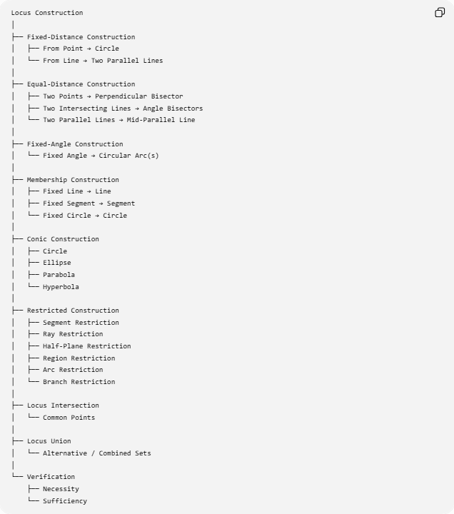
Locus Construction
│
├── Fixed-Distance Construction
│ ├── From Point → Circle
│ └── From Line → Two Parallel Lines
│
├── Equal-Distance Construction
│ ├── Two Points → Perpendicular Bisector
│ ├── Two Intersecting Lines → Angle Bisectors
│ └── Two Parallel Lines → Mid-Parallel Line
│
├── Fixed-Angle Construction
│ └── Fixed Angle → Circular Arc(s)
│
├── Membership Construction
│ ├── Fixed Line → Line
│ ├── Fixed Segment → Segment
│ └── Fixed Circle → Circle
│
├── Conic Construction
│ ├── Circle
│ ├── Ellipse
│ ├── Parabola
│ └── Hyperbola
│
├── Restricted Construction
│ ├── Segment Restriction
│ ├── Ray Restriction
│ ├── Half-Plane Restriction
│ ├── Region Restriction
│ ├── Arc Restriction
│ └── Branch Restriction
│
├── Locus Intersection
│ └── Common Points
│
├── Locus Union
│ └── Alternative / Combined Sets
│
└── Verification
├── Necessity
└── Sufficiency

Important Distinction: Locus vs Locus Construction
# Source: AI Source: Provided by: [Data Path: Persons Table -> ID Column: 1, Name_En Column: Motasem Essam] -> From: [ChatGPT] on [7/25/2026]
These terms describe different things.
Locus
The set of points satisfying a condition.
Example:
$$\boxed{PA=5}$$
has the locus:
$$\boxed{\text{circle centered at }A\text{ with radius }5}.$$
Locus Construction
The process of producing that locus geometrically.
Example:
Set compass to $5$cm, center it at $A$, and draw the circle.
Therefore:
$$\boxed{\text{Locus}=\text{Result}}$$
while:
$$\boxed{\text{Locus Construction}=\text{Process}}$$

Locus Construction vs Geometric Construction
# Source: AI Source: Provided by: [Data Path: Persons Table -> ID Column: 1, Name_En Column: Motasem Essam] -> From: [ChatGPT] on [7/25/2026]
Geometric Construction is the broader concept.
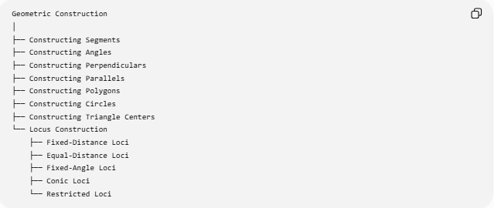
Geometric Construction
│
├── Constructing Segments
├── Constructing Angles
├── Constructing Perpendiculars
├── Constructing Parallels
├── Constructing Polygons
├── Constructing Circles
├── Constructing Triangle Centers
└── Locus Construction
├── Fixed-Distance Loci
├── Equal-Distance Loci
├── Fixed-Angle Loci
├── Conic Loci
└── Restricted Loci
Thus:
$$\boxed{\text{Locus Construction}⊂\text{Geometric Construction}}$$

Key Principles
# Source: AI Source: Provided by: [Data Path: Persons Table -> ID Column: 1, Name_En Column: Motasem Essam] -> From: [ChatGPT] on [7/25/2026]
1. Every locus begins with a condition
$$\boxed{\text{Condition}→\text{Locus}}$$
2. Construction produces the geometric representation
$$\boxed{\text{Locus}→\text{Construction}}$$
3. Multiple conditions use intersections
$$\boxed{\text{Condition A AND Condition B}→L_{1}∩L_{2}}$$
4. Alternative conditions use unions
$$\boxed{\text{Condition A OR Condition B}→L_{1}∪L_{2}}$$
5. Restrictions limit the constructed locus
$$\boxed{L_{\text{restricted}}=L∩R}$$
6. A complete locus requires both directions
$$\boxed{P∈L ⟺ P\text{ satisfies the condition}}$$

Key Points
# Source: AI Source: Provided by: [Data Path: Persons Table -> ID Column: 1, Name_En Column: Motasem Essam] -> From: [ChatGPT] on [7/25/2026]
- Locus Construction is the process of constructing all possible positions of a point satisfying a geometric condition.
- The most important basic constructions are:
$$\boxed{PA=r→\text{Circle}} \\ \boxed{PA=PB→\text{Perpendicular Bisector}} \\ \boxed{d\left(P , l\right)=r→\text{Two Parallel Lines}} \\ \boxed{d\left(P , l_{1}\right)=d\left(P , l_{2}\right)→\text{Angle Bisectors}}$$
- Fixed-angle conditions can produce circular arcs.
- More advanced distance conditions produce conics:
$$\boxed{\begin{aligned}PF_{1}+PF_{2}&=\text{constant}→\text{Ellipse} \\ PF&=d\left(P , l\right)→\text{Parabola} \\ ∣PF_{1}-PF_{2}∣&=\text{constant}→\text{Hyperbola}\end{aligned}}$$
- Multiple conditions can be solved by intersecting loci.
- Alternative conditions can be represented by a union of loci.
- Additional restrictions produce restricted loci.
- A good locus construction should be complete and should be verified.

Conclusion
# Source: AI Source: Provided by: [Data Path: Persons Table -> ID Column: 1, Name_En Column: Motasem Essam] -> From: [ChatGPT] on [7/25/2026]
Locus Construction converts a geometric condition into an actual geometric object representing all possible positions of a moving point. The key is to recognize the distance, equality, angle, or membership condition and then construct the corresponding locus.
The central relationship is:
$$\boxed{\text{Geometric Condition}→\text{Recognize Locus}→\text{Construct Locus}→\text{Apply Restrictions}→\text{Verify}}$$
In this way, locus construction connects geometric reasoning, straightedge-and-compass construction, intersections, unions, restrictions, and conic geometry into one systematic method.

